Sprint: 4

From: 05/20/2024 – 05/31/2024

# Team: ERA: Emergency Response Assist

|  |  |  |
| --- | --- | --- |
| **Team Member** | **Tickets** | **Points** |
| Jatin Madan | 3 | 12 |
| Vaishnavi Sunil Desai | 3 | 12 |
| Isha Ghiria | 3 | 12 |
| Sharvesh Patki | 3 | 12 |

# Sprint Overview:

|  |  |  |  |
| --- | --- | --- | --- |
| **Planned** | | **Completed** | |
| **Items** | **Points** | **Items** | **Points** |
| 12 | 48 | 12 | 48 |

# 

# Sprint Retrospective:

* What have you done during this sprint?
  + Jatin Madan
    - Jatin worked on materializing the UI for the ERA Administrator Dashboard to make it look modern and appealing for users.

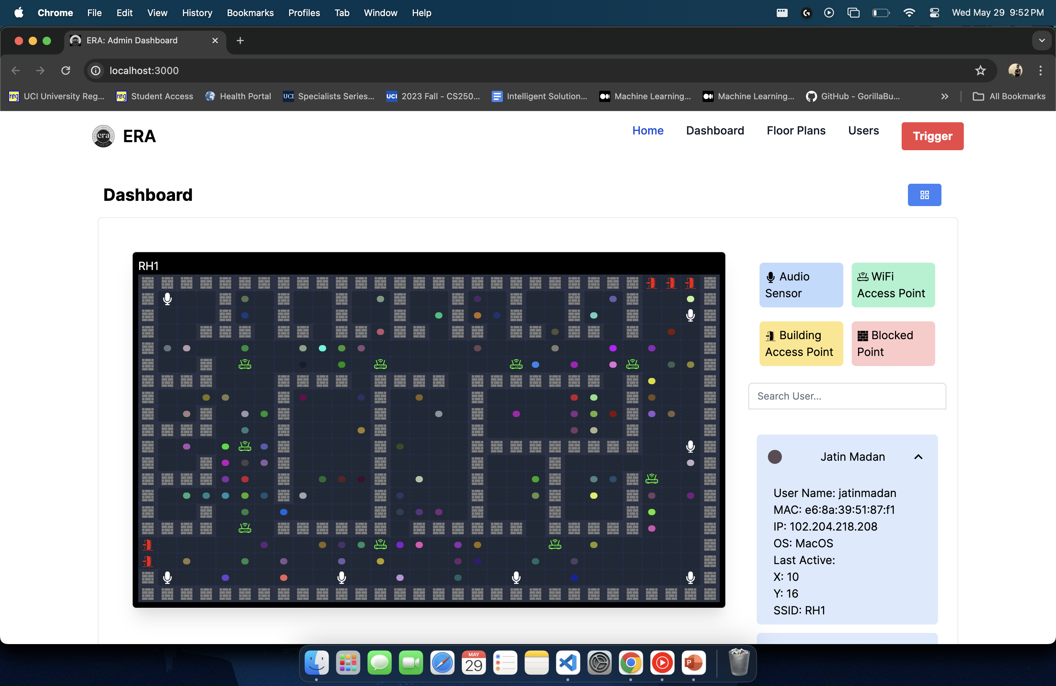

* + - Jatin also worked on integrating the Gunshot Machine Learning API with the Main ERA Server to include capabilities to initiate Triggers on Successful Gunshot Detection.

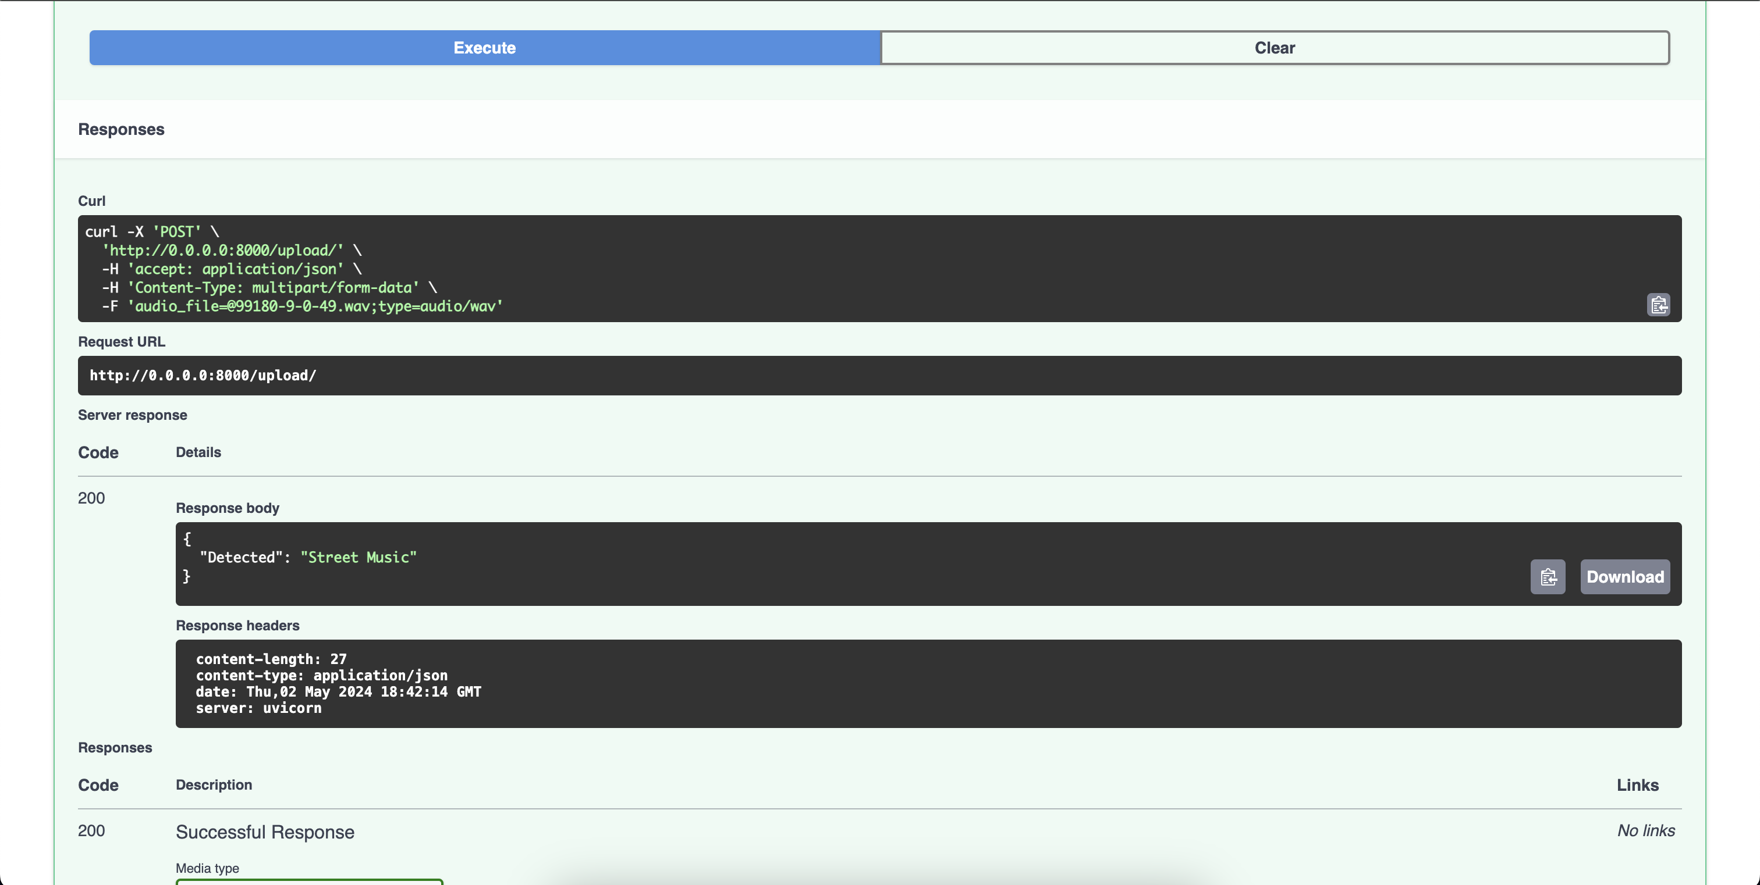

* + - Jatin also worked on improving the algorithm that would be able to predict and triangulate a user’s approximate location in a specified radius.
  + Isha Ghiria
    - Isha worked on updating the A* algorithm used for escape route planning to include multiple exit points during the search, and bifurcating the users between the different exit points to ensure order during the emergency

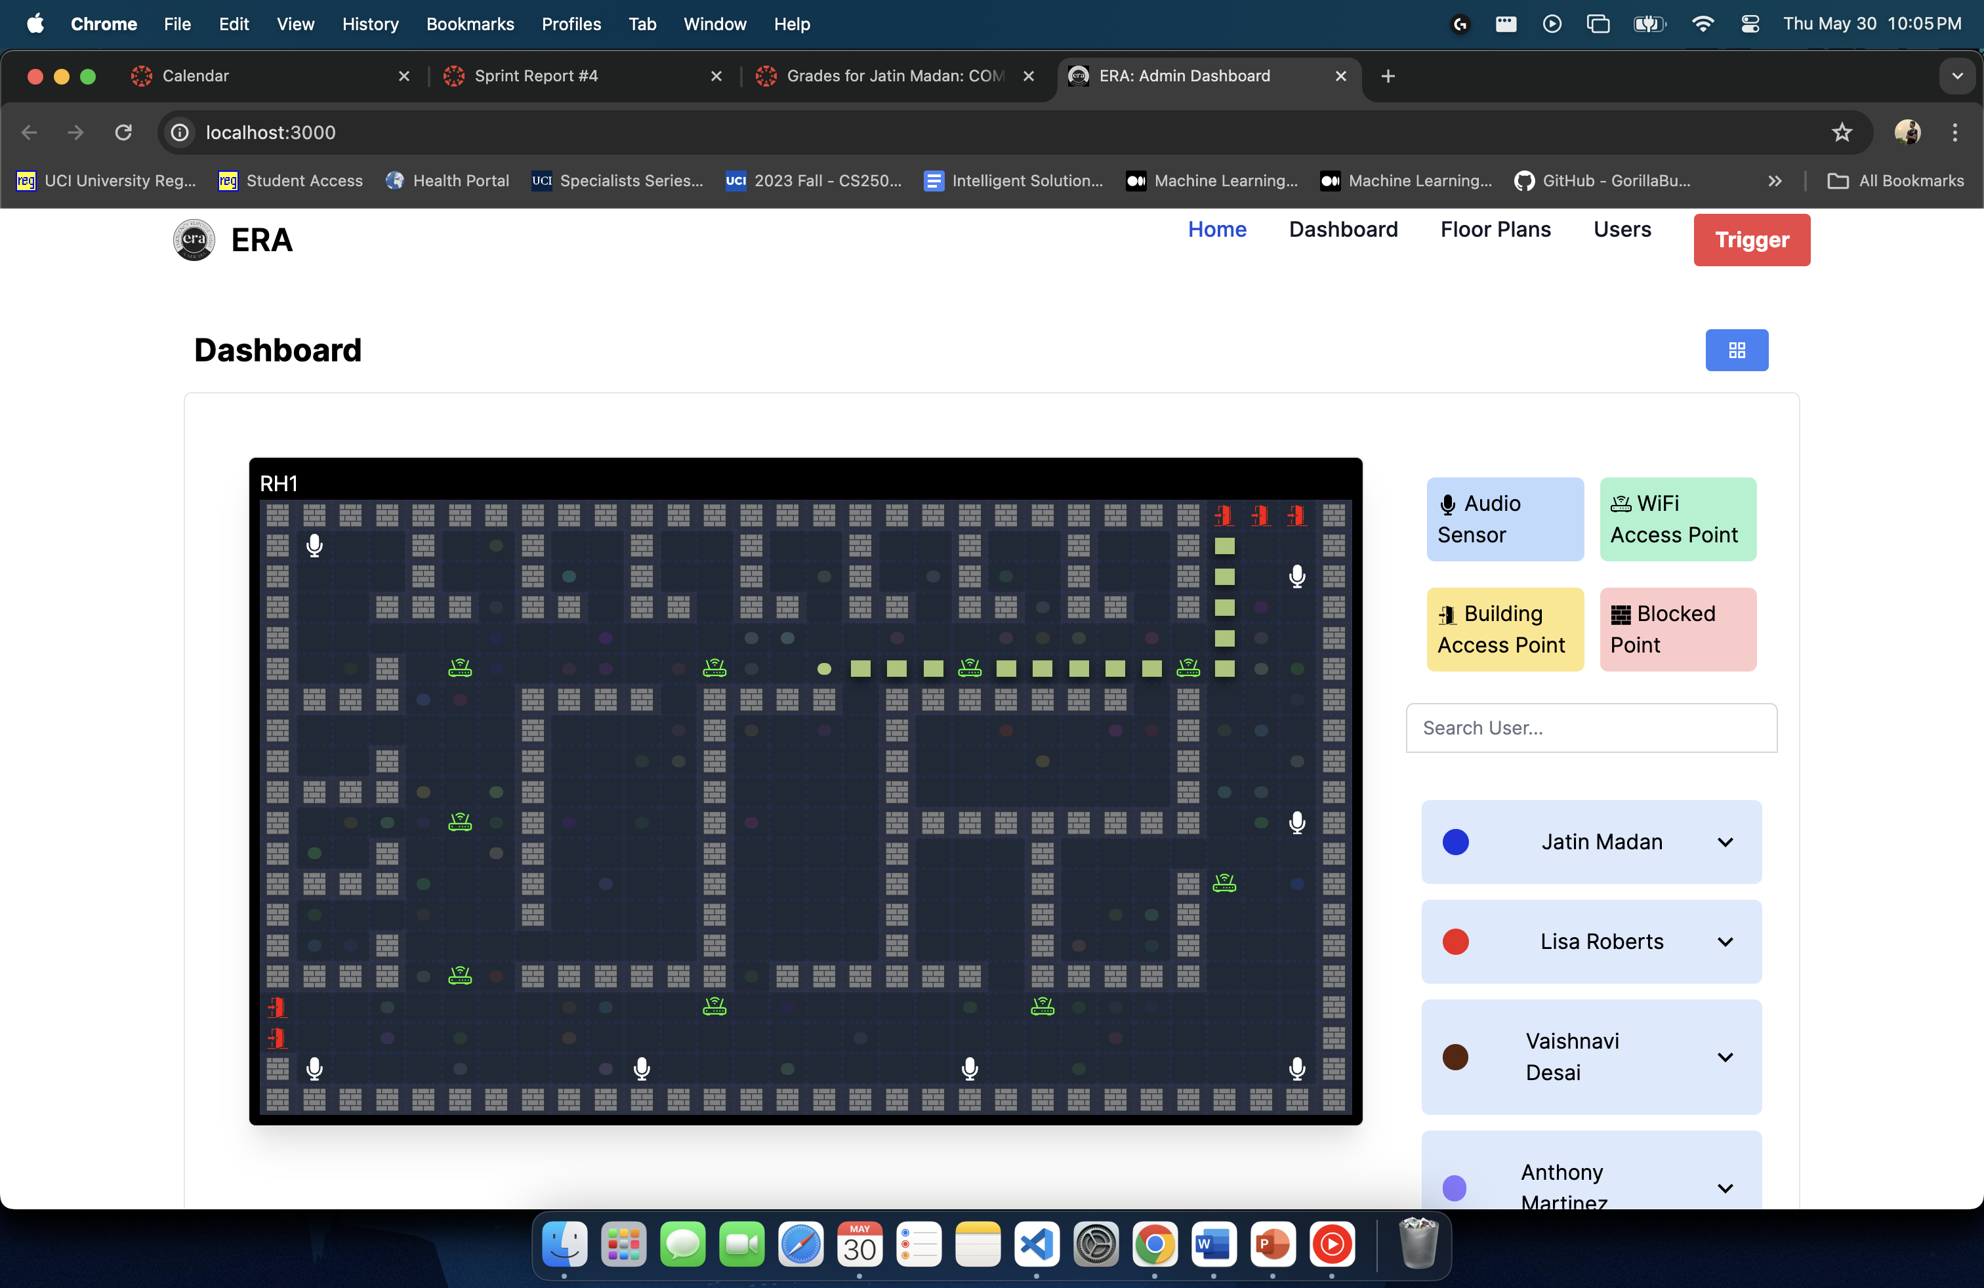

* + - Isha also worked on transforming the Floor Plan Data into Escape Route Algorithm Readable Format. This serves as the basis for the rest of the application to consume and analyze.

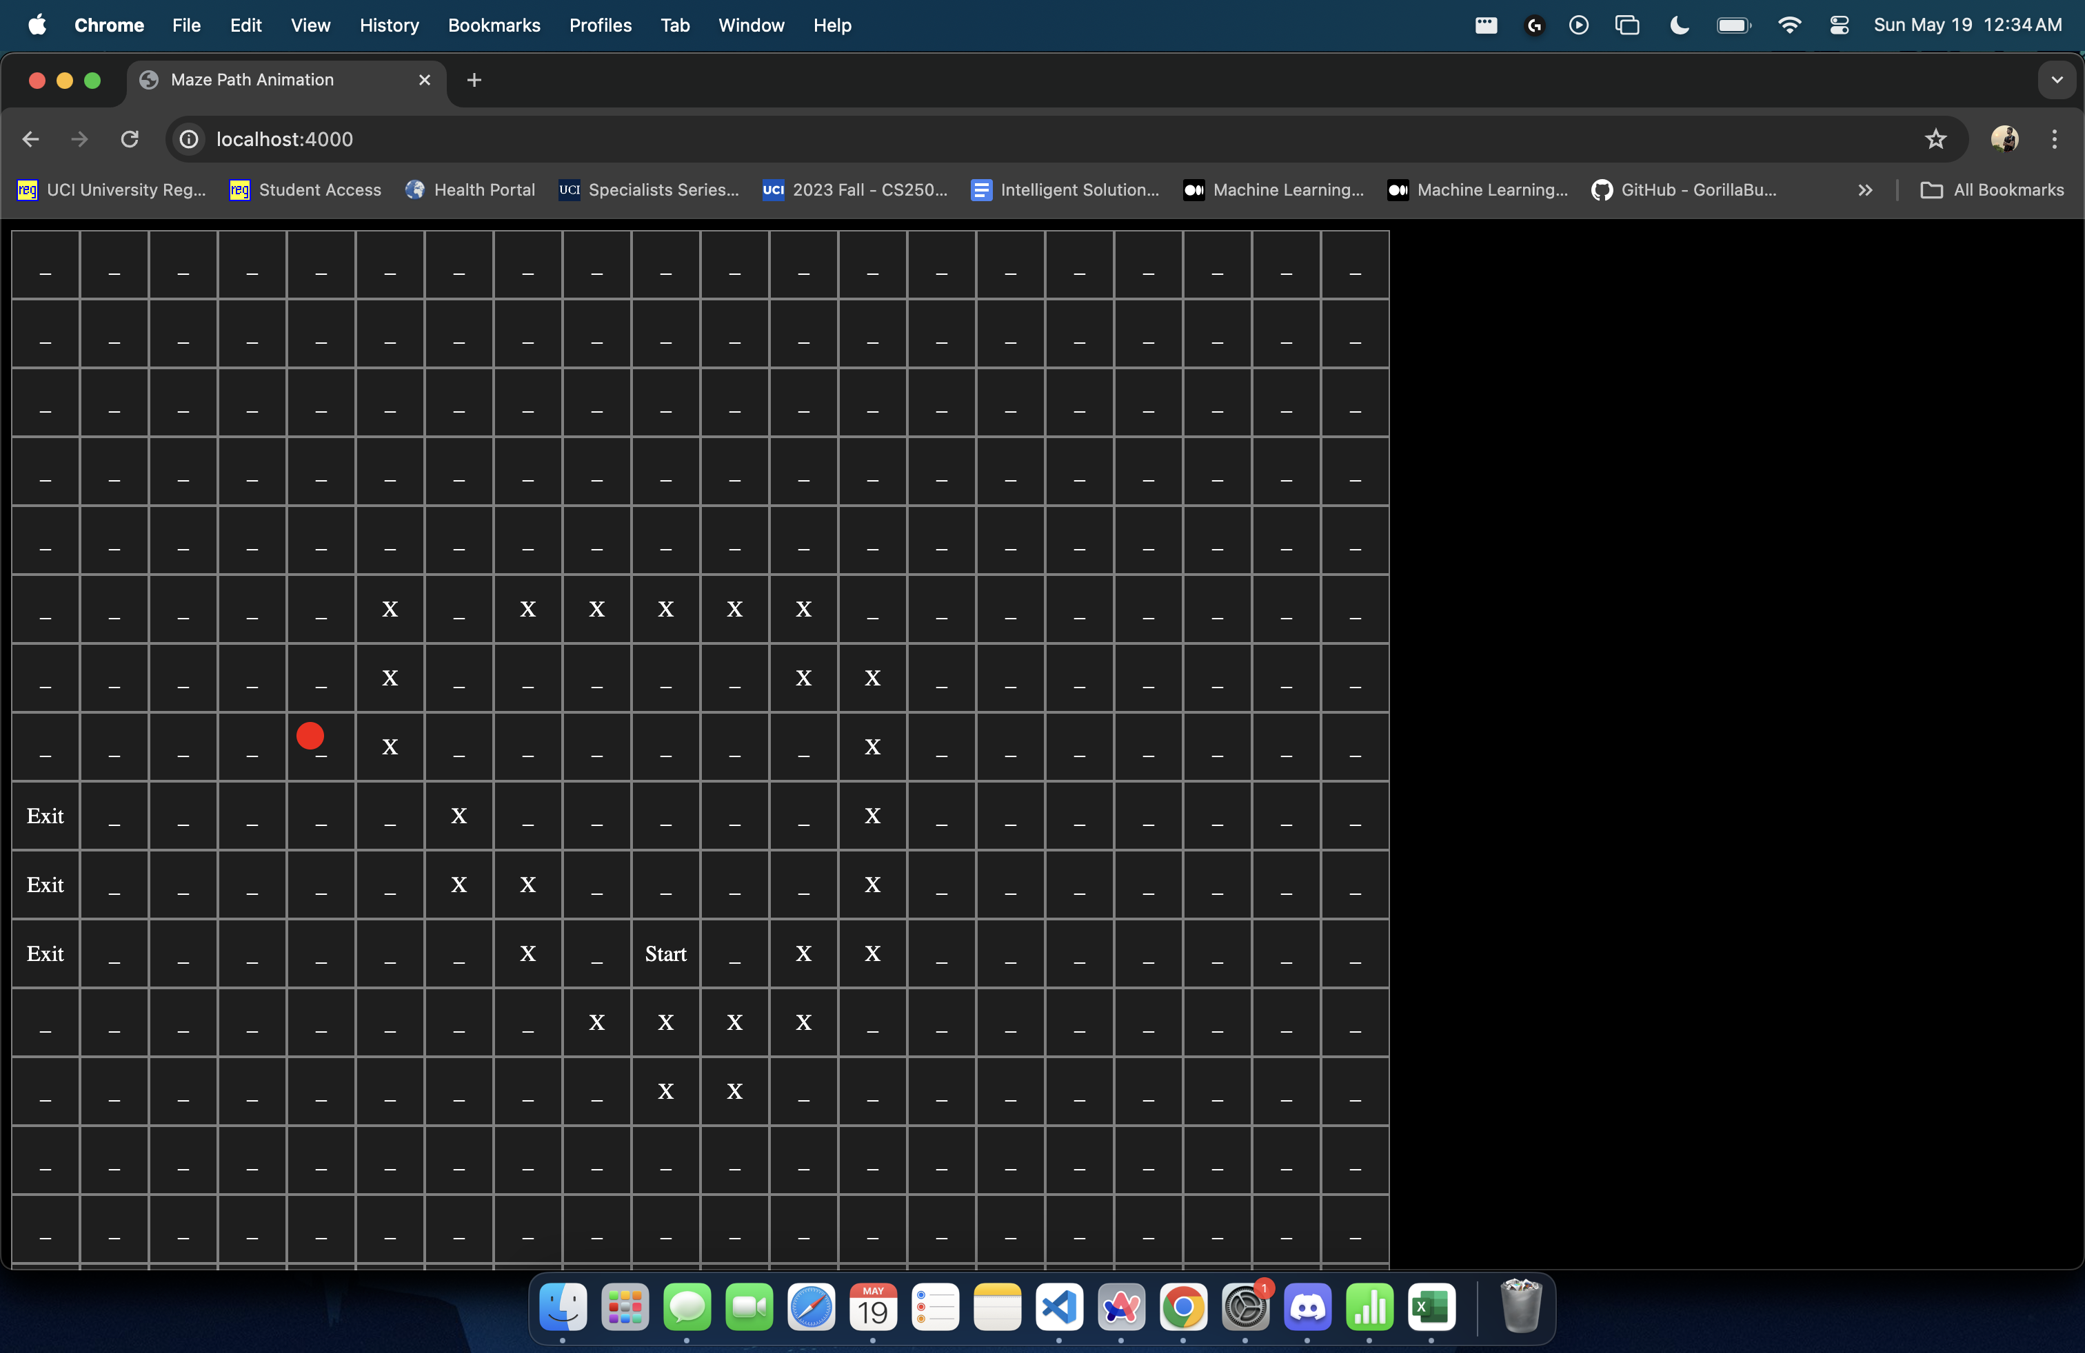

* + - Isha also worked on integrating the API on the Main ERA Server to plan the shortest route to the closest exit point for each user.

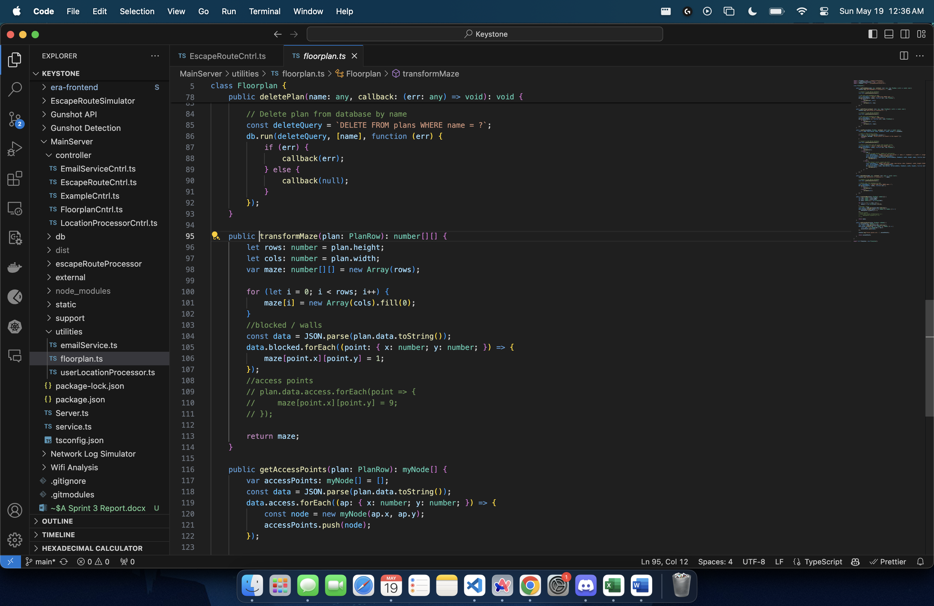

* + Vaishnavi Sunil Desai
    - Vaishnavi worked on materializing and updating the UI Component of Floor Plans Dashboard

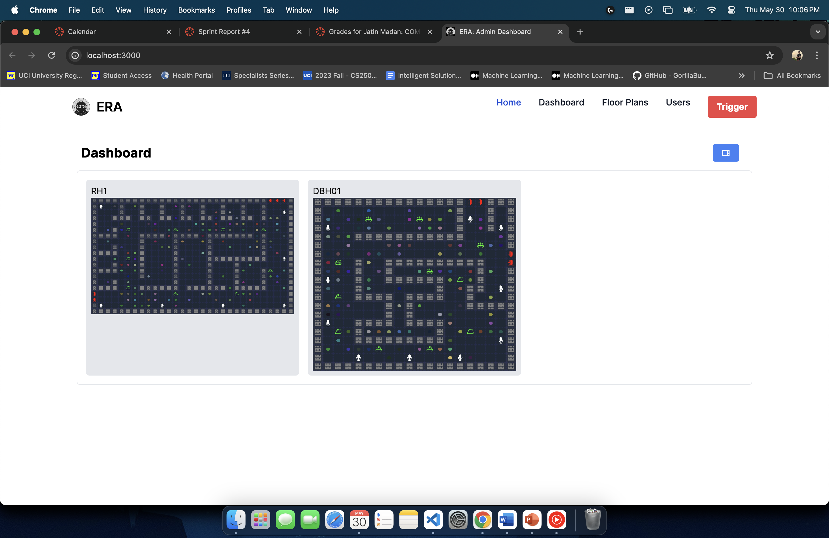

* + - Vaishnavi also worked on integrating the API on the Main ERA Server responsible for polling data from Network Logs Simulator

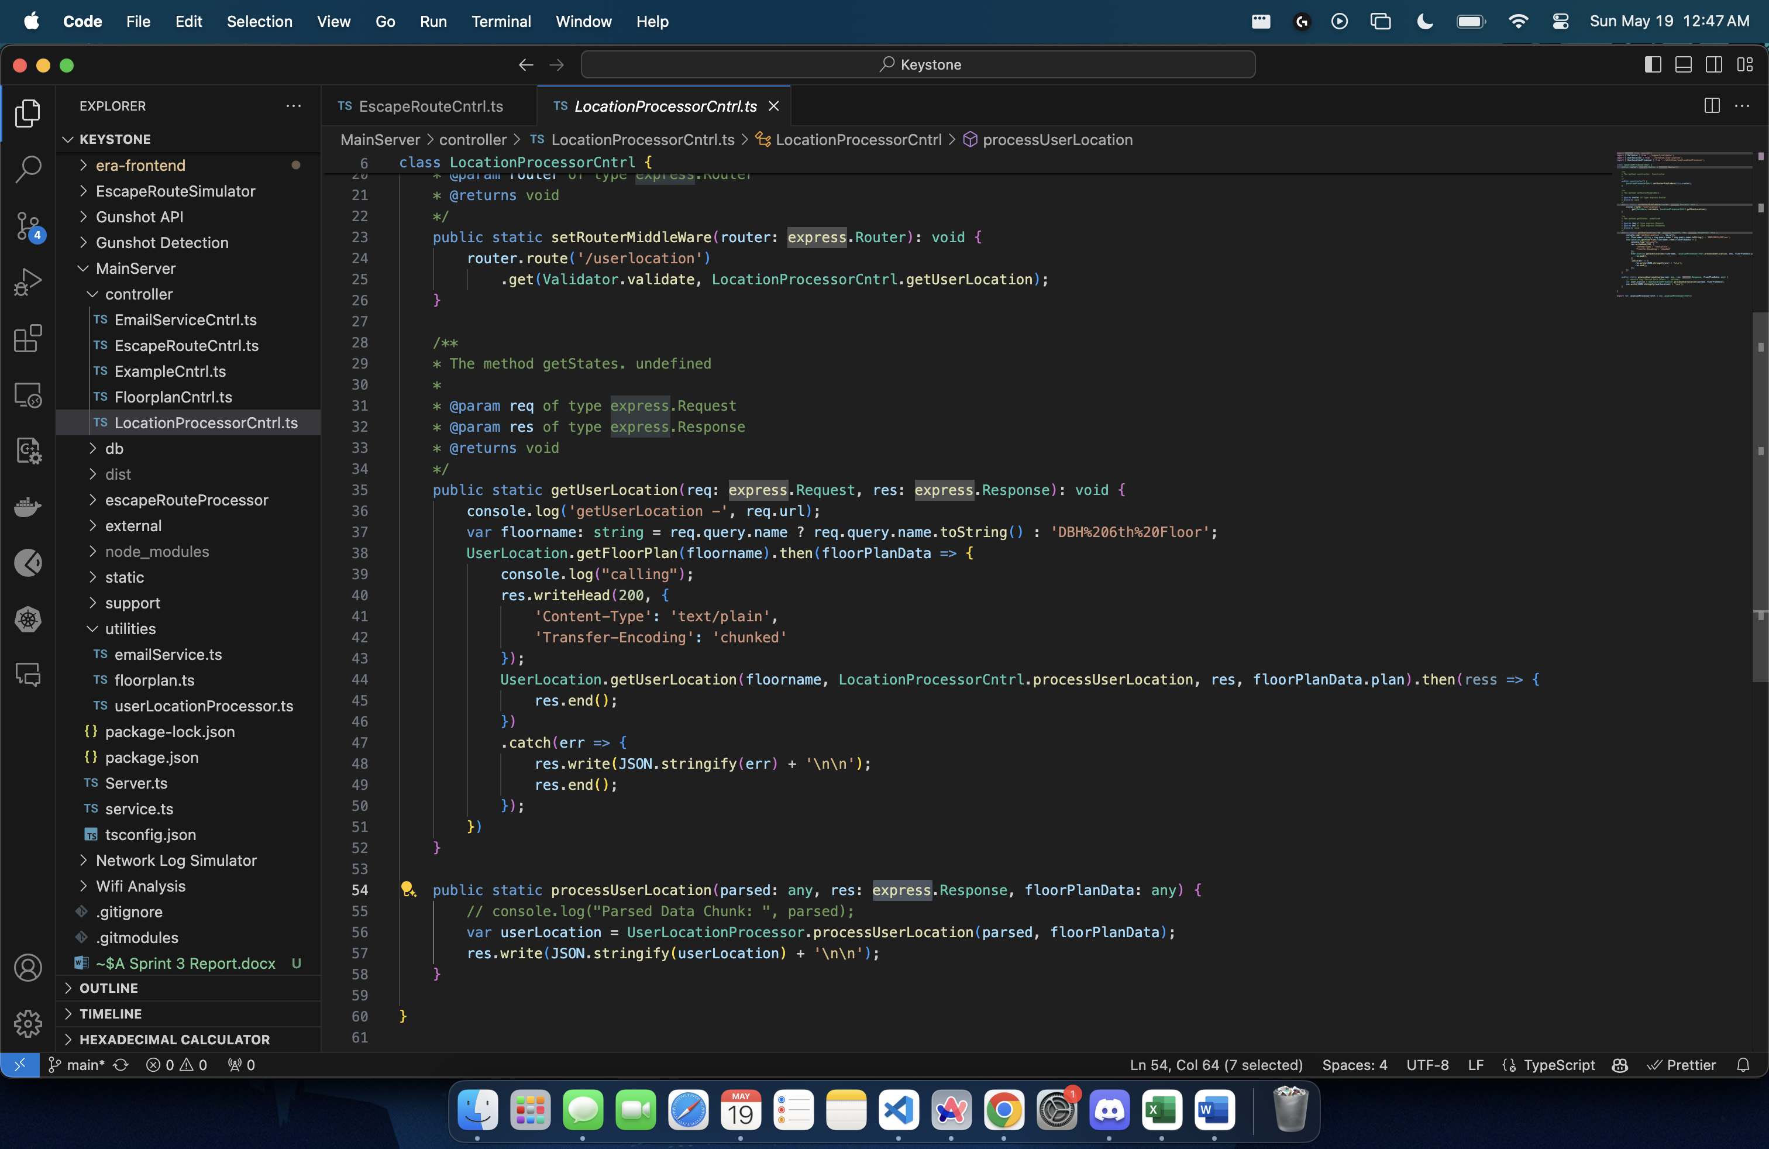

* + Sharvesh Patki
    - Sharvesh worked on materializing and updating the Input UI Component of ERA Administrator Dashboard

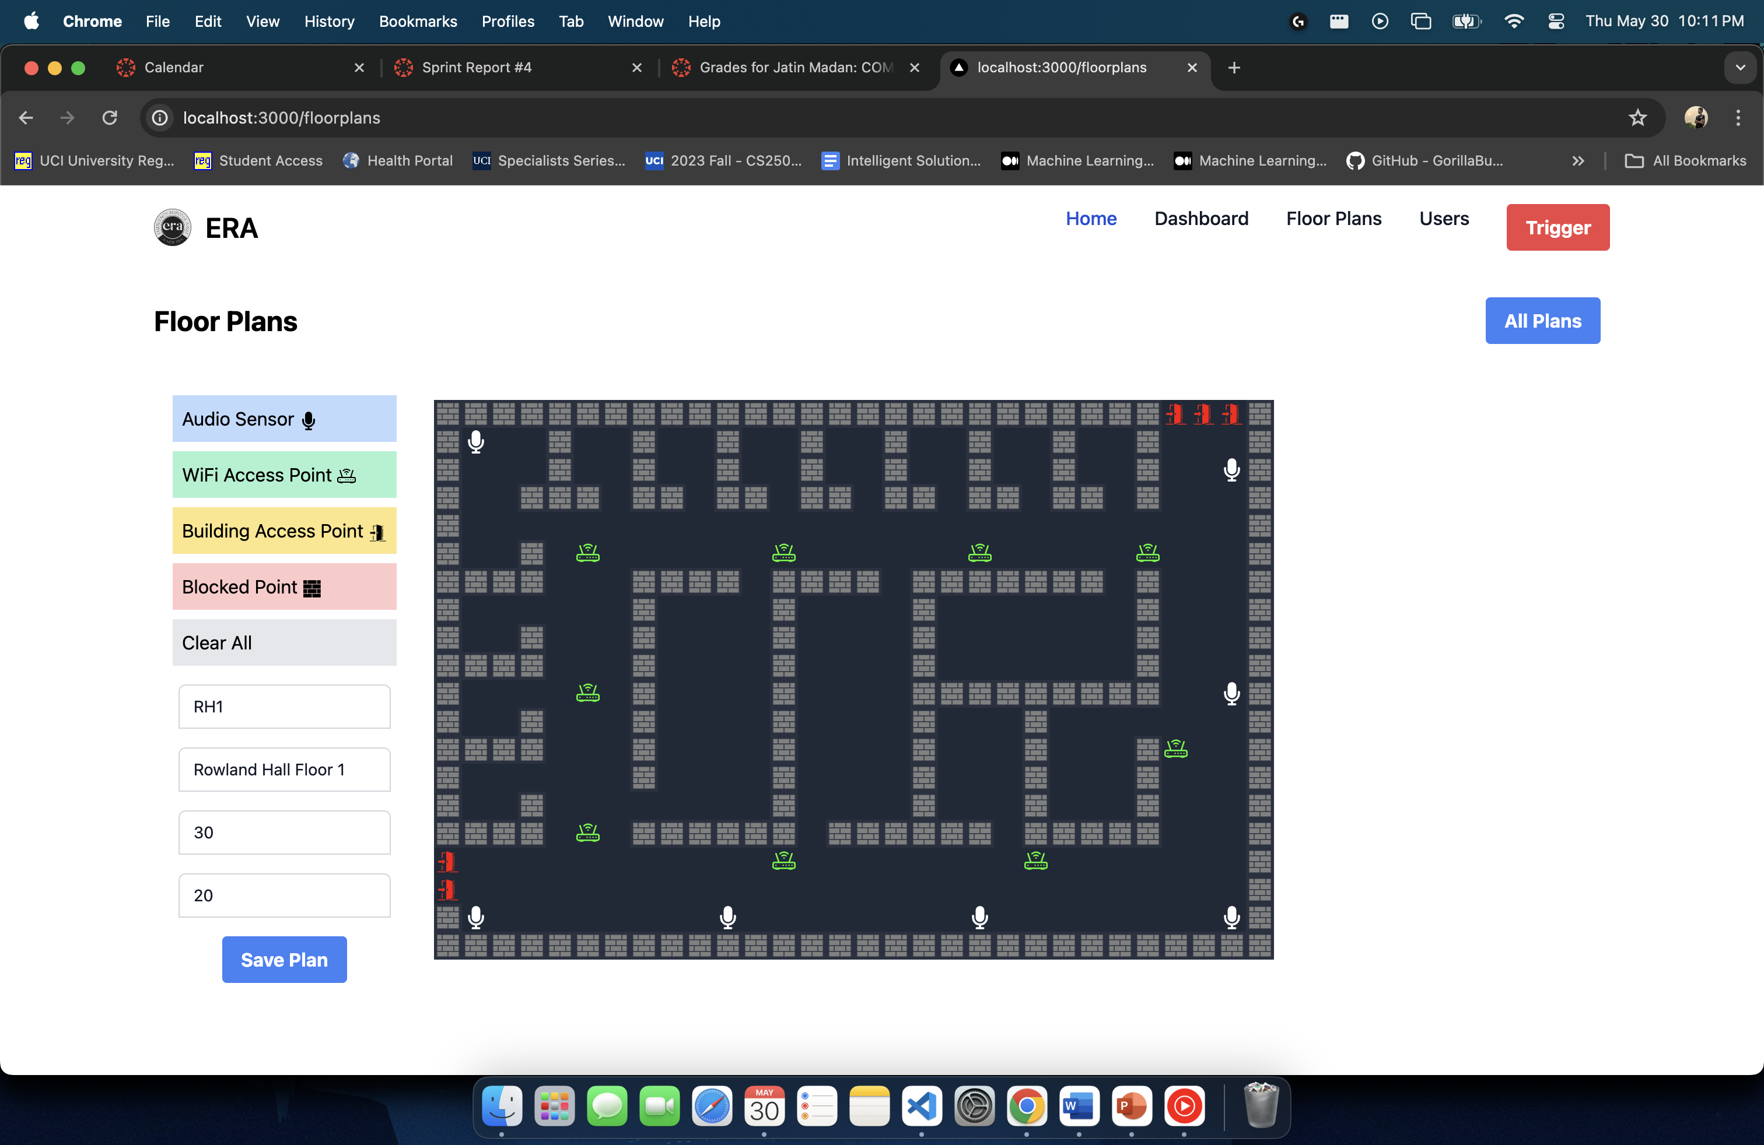

* + - Sharvesh also worked on materializing and updating the UI Component of ERA User View Module

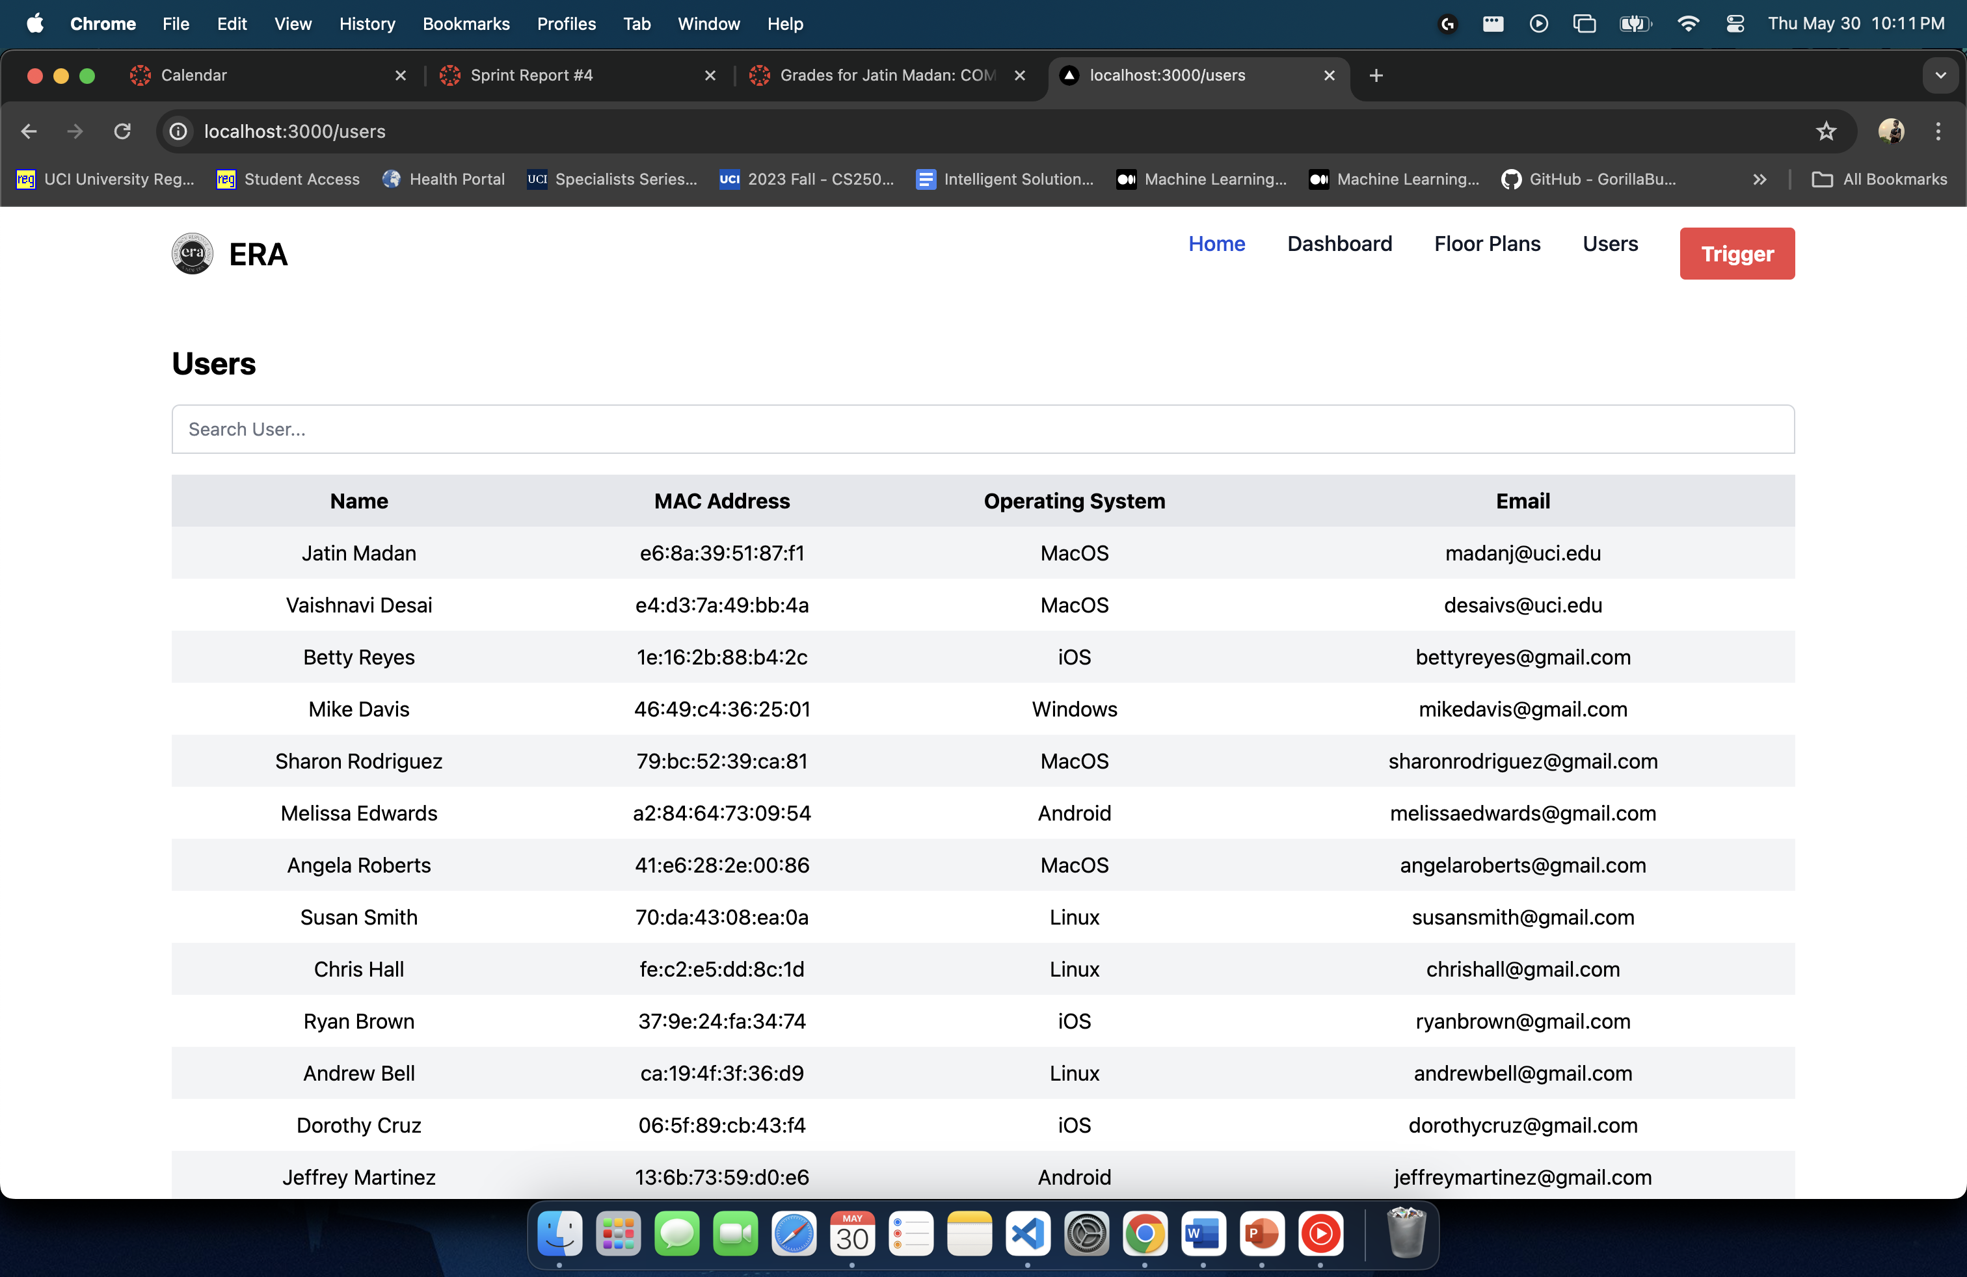

* What went well?
  + Despite, certain issues in task estimation, the team was successfully able to complete all the user stories for this sprint and make considerable progress on building the backbone of the ERA system.
  + The team demonstrated adaptability in responding to changes and adjusting plans as needed to address emerging issues or accommodate new requirements. This flexibility allowed them to maintain progress and keep the sprint on track.
  + The sprint provided opportunities for learning and growth, both individually and as a team. Challenges encountered during the sprint served as valuable learning experiences, helping the team identify areas for improvement and develop new skills.
  + The team applied best practices in agile development, such as conducting regular stand-up meetings, holding retrospectives, and using agile tools effectively. These practices contributed to the overall success of the sprint.
* What didn't go well?
  + Team
    - The Integration task estimation for the modules turned out to be inaccurate, as we went into development for the module, and we had to update our story points to include the updated effort.
* What could/should be improved during the next sprint?
  + Divide User Stories into Smaller Atomic Tasks:
    - Break down user stories into smaller, more manageable tasks to ensure each task is clear, specific, and actionable.
    - Avoid grouping multiple tasks under a single, broad user story to improve focus and task management.
  + Improve Task Estimation and Involve the Whole Team in Sprint Planning:
    - Address issues encountered with task estimation by refining and improving the accuracy of estimates in the next sprint.
    - Involve the entire team in sprint goal planning to gather diverse inputs and ensure more accurate and realistic task estimates.
    - Foster collaborative planning sessions to enhance team understanding and commitment to sprint goals.

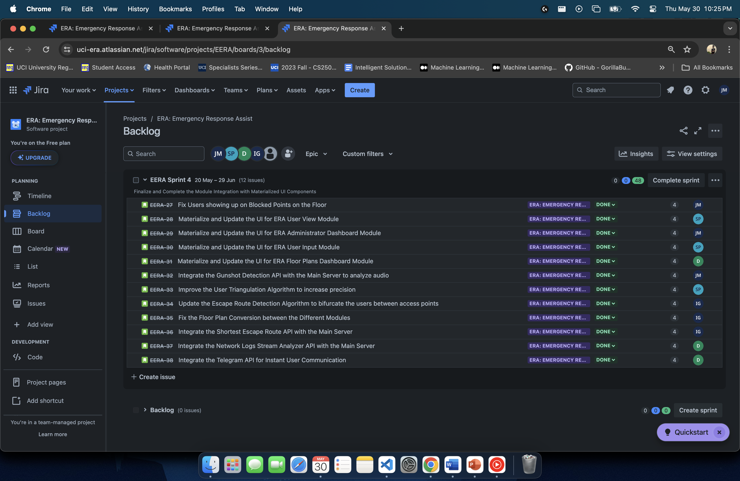

# Sprint Backlog

|  |  |  |  |  |  |
| --- | --- | --- | --- | --- | --- |
| **ID** | **Type** | **Owner** | **Summary** | **Status** | **Estimate** |
| 1 | User Story | Vaishnavi Desai | Integrate the Telegram API for Instant User Communication | Completed | 4 |
| 2 | User Story | Vaishnavi Desai | Integrate the Network Logs Stream Analyzer API with the Main Server | Completed | 4 |
| 3 | User Story | Isha Ghiria | Integrate the Shortest Escape Route API with the Main Server | Completed | 4 |
| 4 | User Story | Isha Ghiria | Fix the Floor Plan Conversion between the Different Modules | Completed | 4 |
| 5 | User Story | Isha Ghiria | Update the Escape Route Detection Algorithm to bifurcate the users between access points | Completed | 4 |
| 6 | User Story | Sharvesh Patki | Improve the User Triangulation Algorithm to increase precision | Completed | 4 |
| 7 | User Story | Jatin Madan | Integrate the Gunshot Detection API with the Main Server to analyze audio | Completed | 4 |
| 8 | User Story | Vaishnavi Desai | Materialize and Update the UI for ERA Floor Plans Dashboard Module | Completed | 4 |
| 9 | User Story | Sharvesh Patki | Materialize and Update the UI for ERA User Input Module | Completed | 4 |
| 10 | User Story | Jatin Madan | Materialize and Update the UI for ERA Administrator Dashboard Module | Completed | 4 |
| 11 | User Story | Sharvesh Patki | Materialize and Update the UI for ERA User View Module | Completed | 4 |
| 12 | User Story | Jatin Madan | Fix Users showing up on Blocked Points on the Floor | Completed | 4 |